TBMI26 – Computer Assignment Reports  
Boosting

February 25 2018

Authors:  
Jakob Dalsgaard, [jakda997@student.liu.se](mailto:jakda997@student.liu.se)  
Erik Sandlund, [erisa920@student.liu.se](mailto:erisa920@student.liu.se)

In order to pass the assignment you will need to answer the following questions and upload the document to LISAM. If you meet the deadline we correct the report within one week after the deadline. Otherwise we give no guarantees when we have time.

1. **Plot how the classification accuracy on training data and test data depend on the number of weak classifier (in the same plot). Be sure to include the number of training data (non-faces + faces) and the number of Haar-Features.**

In figure 1, we can see the classification accuracy on the training data and the test data. For this we used 3000 pictures for the training data with 50 Haar-Features and 5000 pictures for the test data.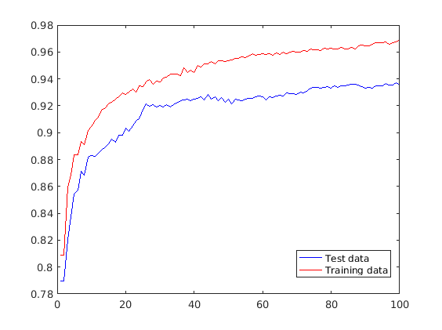  
*Figure 1: The accuracy of the test and training data.*

1. **How many weak classifiers did you chose before testing the data?**

We used 100 weak classifiers since it seemed to be a good compromise between accuracy as well as computation time for training the network.

1. **How many weak classifiers did you use for final strong classifier? Why?**In figure 1, one can see that at around 40 classifiers we start to get diminishing returns when the number of classifiers increase. Therefore we chose to use 40 weak classifiers for our final strong classifier to avoid using redundant complexity.
2. **What is the accuracy on the test data after applying the optimized strong classifier?**This results in an accuracy of 92.48% on the test data.

1. **Plot some of the misclassified faces and non-faces that seem hard to classify correctly.**In figure 2 and 3, some of the misclassified non-faces and faces respectively can be seen. A few common things can be said about the faces as well as the non-faces.  
   For the faces, three major features can be identified among these images. The first one is glasses. These give weird reflections and tend to create large circles around the eyes which makes these faces stand out compared to the ones not wearing glasses. Secondly is that several of these faces are not well lit in the photographs which results in difficulty with extracting the facial features since the image is so dark. Thirdly is facial hair which there either isn’t a Haar-feature generated for or the number of people with facial hair is so low that none of the weak classifiers focuses on it.  
   For the non-faces, the only major feature that stands out is that several of the buildings have windows placed in such a formation that it could be mistaken for a pair of eyes, and in some cases a mouth as well.  
   Considering these things it is understandable as to why these images were misclassified.   
     
     
     
     
     
     
     
     
     
     
     
     
     
   *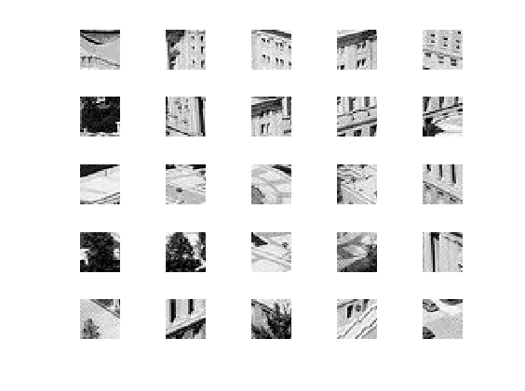Figure 2: A sample of misclassified non-faces.*  
   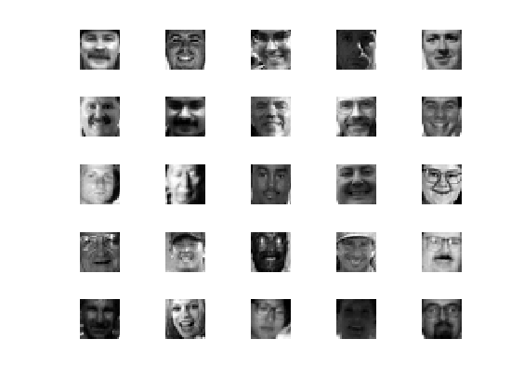  
   *Figure 3: A sample of misclassified faces.*
2. **Defend your results. Are they reasonable?**The results are indeed reasonable. For using only fifty randomly generated Haar-features and due to computational time using only 3000 different images for training the classifiers, we consider getting over 90% accuracy on the test data to be quite good. For a more complex network a higher accuracy is to be expected, but for us the results are very reasonable.
3. **Can we expect perfect results?**Perfect results are always a pipedream, and should not be expected. Considering the low resolution of the images and the rough Haar-features a perfect result would be more of a lucky shot rather than the result of a perfect network. With some of the faces and non-faces discussed in question 5 as well, it is not hard to understand why receiving a perfect result is almost an impossible expectation.